**SOFTWARE REQUIREMENTS SPECIFICATION (SRS) FOR**

**‘AI-ONE’ MOBILE APP**

PREPARED BY:

GROUP LEADER MEHFOOZ ALI (SE-054)

GROUP MEMBER AMMAD MAJID (SE-057)

GROUP MEMBER MUBASHIR ATIQ (SE-059)

Department of Software Engineering

NED University of Engineering and Technology

DATED: 28/12/2020

VERSION 1.0

Table of Contents

**1.** **INTRODUCTION** 4

1.1 Problem Definition 4

1.2 Purpose 4

1.3 Scope 4

1.4 OVERVIEW OF THIS DOCUMENT 5

**2.** **OVERALL DESCRIPTION** 6

2.1 Product Perspective 6

2.2 User Characteristics 6

2.3 User Objectives 7

▪ AS TECNICIAN 7

▪ AS CUSTOMER 7

2.4 General Constraints 7

**3.** **Functional Requirements** 8

3.1 USE CASES 8

3.1.1 Use Case: Sign Up 9

3.1.2 Use Case: Log In 9

3.1.3 Use Case: Log Out 9

3.1.4 Use Case: Search for services 10

3.1.5 Use Case: Browse Categories 10

3.1.6 Use Case: Edit Profile 10

3.1.7 Use Case: profile ratings 11

3.1.8 Use Case: Appointment notification 11

3.1.9 Use Case: Decline appointments 11

3.1.11 Use Case: payment details 12

**4.** **Non-Functional Requirements** 12

4.1.1 Usability Requirements for users 12

4.1.2 Systems administrators 13

4.2 Performance Requirements 13

4.2.1 System 13

4.2.2 Response Time 13

4.2.3 Scalability 13

4.3 Security Requirements 14

4.4 Maintainability 14

**5.** **Interface Requirements** 15

5.1 GUI 15

Screen Mockups: 15

**6.** **PLANNING** 17

6.1 Team Structure 17

6.2 Process Model 17

**7.** **CONCLUSION** 17

# INTRODUCTION

## 1.1 Problem Definition

In this modern era of technology where people have easy access to the internet and number of smartphone users have gone to massive extent. Traditional and obsolete ways are either being removed or replaced with new techniques in the field of trading, transportation, banking, shopping and other services etc. to promote better and effective co-operation among different parties.

The idea behind building this project is to build an application platform where most of the technical service providers i.e. Home repair services, appliances services and many more, locating and functioning in different areas of the city can be on the same platform and where consumers can find, sets appointments and communicate with them simply using mobile app.

## 1.2 Purpose

The purpose of this document is to present a detailed description about the requirements needed to successfully complete the **AI-ONE** app, an android application. It will explain the general description of the project, features of the system, interfaces of the system, the functional, performance requirements for the application, and the constraints under which it must operate and how the system will react. Application usage scenarios, and use case diagrams etc.

1.3 ScopeThis software system will be an android application for any people or any shops or organizations who want to use technical service providers system in their daily life or for their interests. The system will be designed to help the users to:

1. Place their services into the system
2. Search for services in the system
3. Allow technicians to productively complete their daily tasks while communicating with the clients
4. Filter search according to geographic information
5. Sets appointments
6. Tracking of previous records

## 1.4 OVERVIEW OF THIS DOCUMENT

The next chapter, the Overall Description section, of this SRS document gives an overview of the major functionality and attributes of the system. It will provide a detailed explanation about the users’ characteristics, objectives, and general constraints and assumptions.

The third chapter of this document is written primarily for the developers and describes in technical terms the details of the functionality of the product.

The fourth chapter of this document will provide a description of the interfaces of the system.

Last chapters of this document will contain Planning, team structure, process model and conclusion part.

# **OVERALL DESCRIPTION**

## 2.1 Product Perspective

***AI-ONE*** is a mobile application with a web service in order to get services and messaging. The mobile application will work on mobile Android devices. When users run the application, they can use the functionalities of an app. This mobile application is intended to provide users (service provider/technician) a way to create account and upload information about his offered service, working experience and fees etc. Consumers can search for the service they want and contact with technicians and communicate with them and track their appointments using their mobile device. Additionally, the app can optionally notify the user a set time before the due time of an appointment between the two parties.

## 2.2 User Characteristics

Users of this application are any Android device user that loads this application to their devices. All of the users are in the same class, only one type of user exists. Operating environment is, as just mentioned above, is an Android OS mobile device. A typical user should have some experience using web applications and mobile operating systems. A basic knowledge of the Android operating system on a mobile device as well as the ability to authenticate to any online service will be sufficient to use the application effectively.

## 2.3 User Objectives

## AS TECNICIAN

After signing in with username and password as a technician/service provider, the application should automatically import his details, schedules and any information associated which have been uploaded by him. The application should allow technician to edit current details, remove old details and contact with previous customers. The application should notify if there is schedules due soon, and should make it easy to quickly check what schedules are due next.

## AS CUSTOMER

After signing in with username and password as a customer, the application should automatically import his details, list of all services offered, technicians info, contact option, appointments schedules and any information associated which have been uploaded by him. The application should allow clients to edit current details, remove old details and contact with technicians. The application should notify if there is appointment with technician due soon, and should make it easy to quickly check what appointments are due next.

## **2.4 General Constraints**

The application must run on the Android mobile operating system. A user’s Android device must provide network connectivity (both hardware and software) in order for the application to fully function. Important constraint is privacy and security. Users should be accessing only the authenticated data.

# **Functional Requirements**

## 3.1 USE CASES

**Sign up**

**Log In**

**Appointment Notification**

**Search Items**

**Update Profiles**

**Browse categories**

**User**

**Log Out**

**Payment Details**

**Profile Ratings**

**Cancel Appointments**

## 3.1.1 Use Case: Sign Up

In this use case, user enters his/her name, surname, username, password, email address. When the user fills all necessary fields, an activation mail will be sent to users email address. User will be able to log in and start using the system just after activating his/her account.

**Sign Up**

User

## 3.1.2 Use Case: Log In

In this case, user enters his/her username or email and his/her password and logs into the system.

**Log In**

User

## 3.1.3 Use Case: Log Out

In this case, user touches log out button, and logs out of the system. The user will not use the system until he/she logs in again.

**Log Out**

User

## 3.1.4 Use Case: Search for services

In this case, user is able to search services offered and the application shall show a list of all the service providers for that service.

**Search**

User

## 3.1.5 Use Case: Browse Categories

In this case, user is able to browse categories according to his/her wishes. User can also see how many services each category has.

**Browse Categories**

User

## 3.1.6 Use Case: Edit Profile

In this case, user can change his/her username, email address and password. If the user changes his/her username or password, a notification mail will be sent to the user’s email address. The changes will apply if the user clicks on the link in the email.

**Edit profile**

User

## 3.1.7 Use Case: profile ratings

In this case, user can give ratings or comment on how well the service being offered by its provider.

**Rating**

User

## 3.1.8 Use Case: Appointment notification

In this case, user should be able to get a notification about appointment date and time which should had been set after customers negotiation with the service providers. It shall include the days and times when meets. It should also include the name of the technician who will work for customer.

**Appt. Notification**

User

## 3.1.9 Use Case: Decline appointments

In this case, user should be able to cancel an appointment either customer or service provider due to some reasons.

**Cancel Appt.**

User

## 3.1.11 Use Case: payment details

In this case, user should be informed about the full payment details and maintain list of all previous invoices between them.

**Payments**

User

# **Non-Functional Requirements**

## 4.1.1 Usability Requirements for users

1. The product shall have a minimum piece of content where appropriate.
2. The product shall have efficient use of screen estate when displaying content, interfaces, and widgets.
3. The product shall have efficient user interfaces that require the least amount of clicks or steps to complete common tasks.
4. The product shall provide effective help and instructions throughout the navigation schemes.
5. The product shall have interface and architecture that are quickly and easily adopted by the users.
6. The search function in the system shall be easily accessible to the users.
7. Product shall provide less overwhelming help and instructions to first-time users.
8. The product shall restrict the customization of the content structures and interfaces for the users.
9. The product shall have a simple registration process that is straightforward and completely relevant to all user groups.
10. The product shall have a simple log-in process with trouble-free and quick password recovery for all user groups.

## 4.1.2 Systems administrators

1. The product shall enable administrators to be self-sufficient in solving technical issues without a little or no need external assistance.
2. The product shall be able to see and audit all the unauthorized access for all user groups.

## 4.2 Performance Requirements

## 4.2.1 System

The application will run on all Android devices running version Jelly Bean or Later. The application will respond to the size of the screen and/or window the application is running in.

## 4.2.2 Response Time

The application should take less than 4 seconds when running on an Android phone and less than 8 second when on an emulator or tablet. The application will run fine until the user begins to multi-task between 3 or more processes.

## 4.2.3 Scalability

The application will be able to scale to the size of the user as it increases.

## 4.3 Security Requirements

This app contains several members-only areas. Unauthenticated/Non-logged in users are not allowed to access these areas. We want our visitors to have to sign in first to see and then access to our whole application. Users can authenticate by logging in using their username and password and can use whole sum functionality of app like setting appointments and chat with service providers etc.

## 4.4 Maintainability

The development team will follow best practices for clean code and software modularity in order to make the application as maintainable as possible.

# **Interface Requirements**

The interface allows the user to search and view all the service providing yet on app. It also allow users to customize their schedule by allowing the users to add appointment as favorable by a simple touch of the screen. Then the user may customize that appointment to specific detail and specification.

## 5.1 GUI

## Screen Mockups:

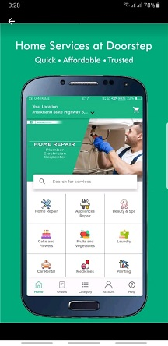 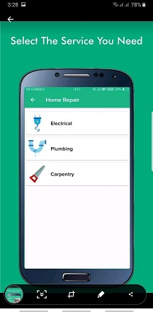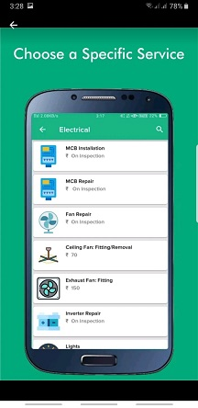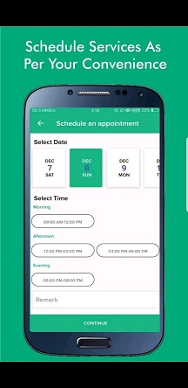

# **PLANNING**

## 6.1 Team Structure

Our team member’s distribution of tasks are as follows:

|  |  |  |
| --- | --- | --- |
| **NAME** | **STUDENT ID** | **TASKS** |
| Mubashir Atiq | SE-059 | Project manager, UI/UX designer |
| Mehfooz Ali | SE-054 | UI/UX designer, front-end developer |
| Ammad Majid | SE-057 | Database designer, back-end developer |

## 6.2 Process Model

The model used for the development is an **iterative model.** It will easily help and support in the further extension of the app. We can gather, analyze, design, develop the new requirements and integrate with the existing system in the next increment through using that model without difficulty.

# **CONCLUSION**

In this document, we have defined how should be ‘AI-ONE’ Project in detail. This is the first version plan about the project, therefore some details may update/add to newer versions of the document also some parts can be removed because of unpredictable reasons. While we are implementing the project, these add/update/remove processes will be shown in the update documents.